**Daily Scrum or Standup Meeting**

Team name: Group 8_________________________

Scrum Master: Cole_______________________

Date: 3-18_______________________________

|  |  |  |  |
| --- | --- | --- | --- |
| **Team Member** | **What did you do since the last scrum?** | **What do you plan to do before the next scrum?** | **What obstacles do you have?** |
| Cole | Finished React tutorial | Get Austin’s code to run on my machine | Time |
| Austin | Worked with Jeremy and Logan on authentication | Work on lot and checkout views | None |
| Logan | Installed Django REST framework | Work on finishing APIs and understanding authentication tokens | Time |
| Jeremy | Same as Logan | Same as Logan | Time |
|  |  |  |  |

# Burndown

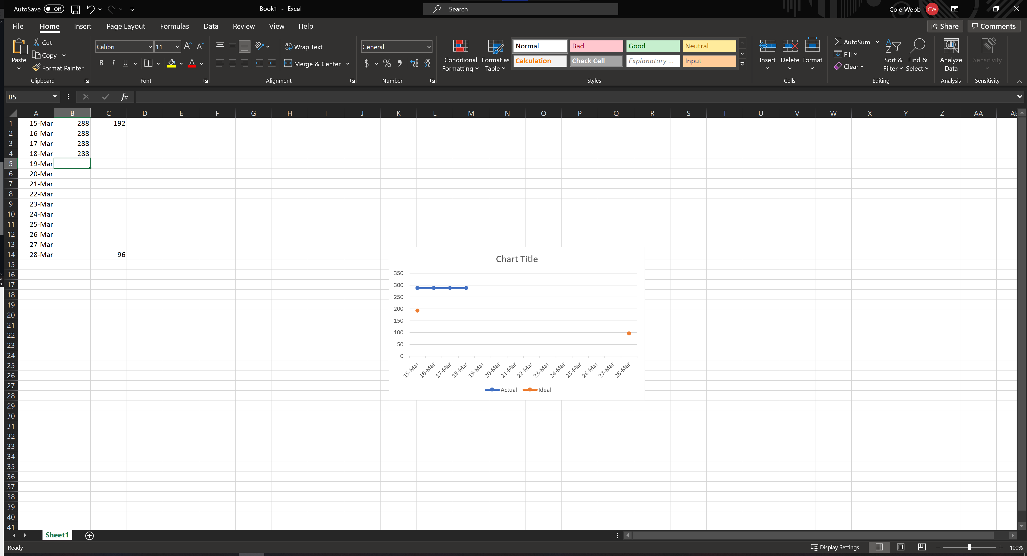

# Screenshot of you project board

